8

EduGenie: Google Gemini Powered Learning Assistant

Project Description
EduGenie is a lightweight AI-powered educational assistant that simplifies learning through generative AI. Designed for students of all academic levels, EduGenie enables users to:
- Ask questions and receive smart, concise answers
- Understand complex concepts through simplified explanations
- Generate quizzes from topics or text
- Receive personalized learning recommendations
- Summarize large educational passages
Built with FastAPI for the backend and a simple HTML+CSS frontend, EduGenize leverages lightweight and cloud-based AI models for local efficiency and cloud power. It works well on devices like the Mac M1, making it accessible to a broad range of learners and developers .
Scenarios
Scenario 1: A student wants to know about oceans and rivers uses EduGenie to ask “Which is the largest ocean?”
Scenario 2: A student wants to know the level of her understanding of “The Pythagoras Theorem” and clicks “Generate Quiz.”
Scenario 3: A learner exploring SQL requests a learning p
path

  - 5. Click **OK** to save. Open a new terminal session to load the variable.

  - ### Option 2: Provide the API key explicitly in code

  - You can pass the API key explicitly when initializing the client. Only do this
  - if you cannot use environment variables.

  - ### Python

  - from google import genai

  - client = genai.Client(api_key="YOUR_API_KEY")

  - interaction = client.interactions.create(
  - model="gemini-3.8-flash",
  - input="Explain how AI works in a few words"
  - )
  - print(interaction.output_text)

  - ### JavaScript

  - import { GoogleGenAI } from "@google/genai";

  - const ai = new GoogleGenAI({ apiKey: "YOUR_API_KEY" });

  - async function main() {
  - const interaction = await ai.interactions.create({
  - model: "gemini-3.8-flash",
  - input: "Explain how AI works in a few words",
  - });
  - console.log(interaction.output_text);
  - }

  - main();

  - ### Java

  - import com.google.genai.Client;
  - import com.google.genai.gaos.models.interactions.CreateModelInteraction;
  - import com.google.genai.gaos.models.interactions.Interaction;
  - import com.google.genai.gaos.models.interactions.InteractionsInput;
  - import com.google.genai.gaos.models.interactions.Model;
  - import com.google.genai.gaos.models.operations.CreateInteractionRequestBody;

  - Client client = Client.builder().apiKey("YOUR_API_KEY").build();

  - CreateModelInteraction params =
  - CreateModelInteraction.builder()
  - .model(Model.of("gemini-3.8-flash"))
  - .input(InteractionsInput.of("Explain how AI works in a few sentences."))
  - .build();

  - Interaction interaction =
  - client.interactions.create(CreateInteractionRequestBody.of(params)).interaction().get();

  - System.out.println(interaction.outputText().orElse(""));

  - ### REST

  - curl "https://generativelanguage.googleapis.com/v1beta/interactions" \
  - -H 'Content-Type: application/json' \
  - -H "x-goog-api-key: YOUR_API_KEY" \
  - -X POST \
  - -d '{
  - "model": "gemini-3.8-flash",
  - "input": "Explain how AI works in a few words"
  - }'

  - ## Security and secret management

  - Treat your Gemini API key like a password. If compromised, others can consume
  - your project's quota, incur unexpected billing charges, and access private
  - resources.

  - ### Critical security rules

  - - **Keep keys confidential**: Never check API keys into source control systems like Git.
  - - **Never expose keys client-side in production**: Do not hardcode API keys directly in web or mobile apps. Keys compiled in client-side code can be extracted by users. To secure client-side apps, run a backend proxy server to make the actual API calls.

  - ### Secret management best practices

  - - **Environment variables**: Read keys from environment variables rather than configuration files.
  - - **Secret Manager** : For production, store your keys in a secure secret store such as [Google Cloud Secret Manager](https://cloud.google.com/secret-manager).
  - - **Billing alerts**: Set up billing alerts in the Google Cloud Console to notify you if usage or costs spike.

  - ### Leak response checklist

  - If you suspect your API key has been leaked:

  - 1. **Generate a new key**: Create a replacement key in Google AI Studio or the Cloud Console.
  - 2. **Update your application**: Deploy your code using the new key.
  - 3. **Disable or delete the compromised key**: Disable the leaked key in the Cloud Console once the new key is verified. Do not delete the old key until the new key is fully active to avoid application downtime.
  - 4. **Audit usage**: Check billing logs and API usage in the Google Cloud Console to identify unauthorized activity.

  - ## Restricting and securing your keys

  - Adding restrictions to your API keys minimizes the potential damage if a key is
  - compromised.

  - ### Apply request origin restrictions

  - Origin restrictions limit which IP addresses, websites, or applications can use
  - your key.

  - 1. Go to the [Google Cloud Console Credentials page](https://console.cloud.google.com/apis/credentials).
  - 2. Select your project, and click the name of the API key you want to restrict.
  - 3. Under **Application restrictions** , select **IP addresses** (or the appropriate restriction type for your environment).
  - 4. Specify the allowed IP addresses or ranges, then click **Save**.

  - ### Securing unrestricted standard API keys

  - To continue using the Gemini API, you must secure any unrestricted keys.

  - #### Method A: Restrict the key to the Gemini API only (AI Studio)

  - If you only use the key for the Gemini API, secure it directly in AI Studio:

  - 1. On the **API Keys** page in [Google AI Studio](https://aistudio.google.com/api-keys), locate keys marked with the **Unrestricted** label.
  - 2. Hover over the label and click **Add restrictions** in the dialog.
  - 3. Select **Restrict to Gemini API only**.
  - 4. Click **Restrict key** to confirm.

  - > [!NOTE]
  - > **Note:** To restrict an API key, you must have the `apikeys.keys.update` permission on the associated Google Cloud project. This permission is included in roles like **API Keys Admin** or **Editor**.

  - #### Method B: Restrict the key for other services (Google Cloud Console)

  - If the key is shared with other Google APIs (not recommended), restrict it in
  - the Cloud Console. **Note: Gemini API requests using this key will fail after
  - these restrictions are applied.**

  - 1. Visit the [Google Cloud Console Credentials page](https://console.cloud.google.com/apis/credentials).
  - 2. Select the project and the API key.
  - 3. Under **API restrictions** , use the **Select API restrictions** drop-down to select the APIs you want this key to access. Do not select the **Generative
  - Language API**.
  - 4. Click **Save**. Create a separate, restricted key in AI Studio to continue using the Gemini API.

  - ### Blocked dormant keys

  - Starting May 7, 2026, the Gemini API blocks unrestricted API keys that have
  - been dormant for an extended period. These keys show a **Blocked** tag in AI
  - Studio. You must generate a new key or use an existing restricted key to
  - continue.

  - ## Migrate to an auth key

  - Follow these steps to create a new auth API key and update your applications:

  - 1. Go to the [AI Studio API Keys page](https://aistudio.google.com/api-keys).
  - 2. Check the **Key Type** column to identify any keys listed as **Standard**.
  - 3. Click **Create API key** to generate a new key. All new keys created in AI Studio are automatically created as auth keys.
  - 4. Copy the new auth API key.
  - 5. Update your application code, environment variables, and any deployment configurations to use the new auth API key.
  - 6. Test your application to confirm it works correctly with the new key.
  - 7. Once verified, delete or revoke your old traffic key to prevent misuse.

  - > [!NOTE]
  - > **Note:** If you don't see your keys, you may need to import your Cloud projects into AI Studio. Refer to the [import projects](https://ai.google.dev/gemini-api/docs/api-key#import-projects) section for instructions.

  - ## Limitations

  - Google AI Studio imposes the following project and key management limitations:

  - - You can create a maximum of 10 projects at a time from the Google AI Studio **Projects** page.
  - - The **API keys** and **Projects** pages display a maximum of 100 keys and 50 projects.
  - - Only API keys that are unrestricted or restricted specifically to the Generative Language API (Gemini API) are displayed.

  - For advanced project management or to modify keys with other restrictions, use
  - the [Google Cloud Console credentials page](https://console.cloud.google.com/apis/credentials).
  - To use the Gemini API, you must authenticate your requests. You can
  - authenticate using a standard or authorization API key.

  - [Create or view a Gemini API Key](https://aistudio.google.com/apikey)

  - ## API key types: standard versus authorization

  - API keys provide access to the Gemini API, but their security characteristics
  - differ. The Gemini API is transitioning from standard API keys to authorization
  - keys to improve security:

  - - **Standard API keys**: Associate requests with a Google Cloud project for billing and quota purposes. Standard keys don't identify a caller, which limits the granularity of permissions and access control they can support.
  - - **Authorization (auth) keys**: Bound directly to a Google Cloud service account. When you use an authorization key, your requests are processed under the identity of that bound service account, enabling granular access control. Authorization keys are restricted to the Generative Language API (Gemini API) by default and provide fast-acting leaked key enforcement that quickly stops the usage of leaked keys detected by our systems.

  - To ensure secure usage, Gemini API will move from standard keys to auth keys:

  - - **Auth keys default**: Starting May 28, 2026, all new API keys created in Google AI Studio are automatically created as auth keys.
  - - **Unrestricted keys rejected** : The Gemini API rejects requests from **unrestricted standard keys**. Standard API keys that have explicit restrictions applied continue to work. This restriction prevents the unauthorized use of keys that might be shared publicly or linked to other services.
  - - **On September 2026** : the Gemini API will reject requests from **standard
  - keys** . You must [migrate to auth keys](https://ai.google.dev/gemini-api/docs/api-key#migrate-to-auth-key) before this date to avoid service interruption. Make sure to migrate to auth keys before September 2026.

  - > [!NOTE]
  - > **Note:** Requests authenticated by authorization keys are not recorded in Google Cloud service account usage metrics.

  - ## Managing API keys in Google AI Studio

  - You can manage your projects and keys directly in [Google AI Studio](https://aistudio.google.com/apikey).

  - ### Google Cloud projects

  - Every Gemini API key is associated with a [Google Cloud project](https://cloud.google.com/resource-manager/docs/creating-managing-projects).
  - Google Cloud projects manage billing, collaborators, and permissions. Google AI
  - Studio provides a lightweight interface to access these projects.

  - - **Default project** : If you are a new user, Google AI Studio automatically creates a default Google Cloud project and API key after you accept the Terms of Service. You can rename this project by navigating to the **Projects** view in your dashboard.
  - - **Existing projects**: If you already have a Google Cloud account, AI Studio does not create a default project. Instead, you must import your existing projects.

  - ### Importing projects

  - By default, Google AI Studio does not display all of your Google Cloud
  - projects. You must import the projects you want to use:

  - 1. Go to [Google AI Studio](https://aistudio.google.com).
  - 2. Open the **Dashboard** from the left panel and select **Projects**.
  - 3. Click the **Import projects** button.
  - 4. Search for and select the Google Cloud project you want to import, then click **Import**.
  - 5. Once imported, navigate to the **API Keys** page in the dashboard to create a key in that project.

  - ### Troubleshooting key creation permissions

  - If the **Create API key** button is unavailable and displays the message:
  - *"You do not have permission to create a key in this project"*, you lack the
  - required IAM permissions.

  - Ask your Google Cloud project or organization administrator to grant you a role
  - containing the following permissions (such as Project Editor):

  - - `resourcemanager.projects.get`: Allows AI Studio to verify the project.
  - - `apikeys.keys.create`: Allows key generation.
  - - `serviceusage.services.enable`: Ensures the Generative Language API is enabled.
  - - `iam.serviceAccounts.create`: Required to create the linked service account.
  - - `iam.serviceAccountApiKeyBindings.create`: Binds the service account to the API key.

  - If you cannot get administrative access, you can create a new Google Cloud
  - project that is not associated with an organization to generate your keys.

  - ## Setting up your environment

  - Once you have a key, configure your environment to use it securely in your
  - applications.

  - ### Option 1: Use environment variables (recommended)

  - Set the environment variable `GEMINI_API_KEY` or `GOOGLE_API_KEY`. The Gemini
  - API client libraries automatically detect and use these variables. If both are
  - set, `GOOGLE_API_KEY` takes precedence.

  - Select your operating system to set the variable:

  - ### Linux/macOS - Bash

  - Verify if you have a bash configuration file:

  - ~/.bashrc

  - If not, create one and open it:

  - touch ~/.bashrc && open ~/.bashrc

  - Add the export command at the end of the file:

  - export GEMINI_API_KEY=<YOUR_API_KEY_HERE>

  - Save the file, then apply the changes:

  - source ~/.bashrc

  - ### macOS - Zsh

  - Verify if you have a zsh configuration file:

  - ~/.zshrc

  - If not, create one and open it:

  - touch ~/.zshrc && open ~/.zshrc

  - Add the export command:

  - export GEMINI_API_KEY=<YOUR_API_KEY_HERE>

  - Save the file, then apply the changes:

  - source ~/.zshrc

  - ### Windows

  - 1. Search for "Environment Variables" in the Windows search bar.
  - 2. Click **Environment Variables** in the System Properties dialog.
  - 3. Under **User variables** or **System variables** , click **New...**.
  - 4. Set the variable name to `GEMINI_API_KEY` and the value to your API key.
  - 5. Click **OK** to save. Open a new terminal session to load the variable.

  - ### Option 2: Provide the API key explicitly in code

  - You can pass the API key explicitly when initializing the client. Only do this
  - if you cannot use environment variables.

  - ### Python

  - from google import genai

  - client = genai.Client(api_key="YOUR_API_KEY")

  - interaction = client.interactions.create(
  - model="gemini-3.8-flash",
  - input="Explain how AI works in a few words"
  - )
  - print(interaction.output_text)

  - ### JavaScript

  - import { GoogleGenAI } from "@google/genai";

  - const ai = new GoogleGenAI({ apiKey: "YOUR_API_KEY" });

  - async function main() {
  - const interaction = await ai.interactions.create({
  - model: "gemini-3.8-flash",
  - input: "Explain how AI works in a few words",
  - });
  - console.log(interaction.output_text);
  - }

  - main();

  - ### Java

  - import com.google.genai.Client;
  - import com.google.genai.gaos.models.interactions.CreateModelInteraction;
  - import com.google.genai.gaos.models.interactions.Interaction;
  - import com.google.genai.gaos.models.interactions.InteractionsInput;
  - import com.google.genai.gaos.models.interactions.Model;
  - import com.google.genai.gaos.models.operations.CreateInteractionRequestBody;

  - Client client = Client.builder().apiKey("YOUR_API_KEY").build();

  - CreateModelInteraction params =
  - CreateModelInteraction.builder()
  - .model(Model.of("gemini-3.8-flash"))
  - .input(InteractionsInput.of("Explain how AI works in a few sentences."))
  - .build();

  - Interaction interaction =
  - client.interactions.create(CreateInteractionRequestBody.of(params)).interaction().get();

  - System.out.println(interaction.outputText().orElse(""));

  - ### RESTTo use the Gemini API, you must authenticate your requests. You can
  - authenticate using a standard or authorization API key.

  - [Create or view a Gemini API Key](https://aistudio.google.com/apikey)

  - ## API key types: standard versus authorization

  - API keys provide access to the Gemini API, but their security characteristics
  - differ. The Gemini API is transitioning from standard API keys to authorization
  - keys to improve security:

  - - **Standard API keys**: Associate requests with a Google Cloud project for billing and quota purposes. Standard keys don't identify a caller, which limits the granularity of permissions and access control they can support.
  - - **Authorization (auth) keys**: Bound directly to a Google Cloud service account. When you use an authorization key, your requests are processed under the identity of that bound service account, enabling granular access control. Authorization keys are restricted to the Generative Language API (Gemini API) by default and provide fast-acting leaked key enforcement that quickly stops the usage of leaked keys detected by our systems.

  - To ensure secure usage, Gemini API will move from standard keys to auth keys:

  - - **Auth keys default**: Starting May 28, 2026, all new API keys created in Google AI Studio are automatically created as auth keys.
  - - **Unrestricted keys rejected** : The Gemini API rejects requests from **unrestricted standard keys**. Standard API keys that have explicit restrictions applied continue to work. This restriction prevents the unauthorized use of keys that might be shared publicly or linked to other services.
  - - **On September 2026** : the Gemini API will reject requests from **standard
  - keys** . You must [migrate to auth keys](https://ai.google.dev/gemini-api/docs/api-key#migrate-to-auth-key) before this date to avoid service interruption. Make sure to migrate to auth keys before September 2026.

  - > [!NOTE]
  - > **Note:** Requests authenticated by authorization keys are not recorded in Google Cloud service account usage metrics.

  - ## Managing API keys in Google AI Studio

  - You can manage your projects and keys directly in [Google AI Studio](https://aistudio.google.com/apikey).

  - ### Google Cloud projects

  - Every Gemini API key is associated with a [Google Cloud project](https://cloud.google.com/resource-manager/docs/creating-managing-projects).
  - Google Cloud projects manage billing, collaborators, and permissions. Google AI
  - Studio provides a lightweight interface to access these projects.

  - - **Default project** : If you are a new user, Google AI Studio automatically creates a default Google Cloud project and API key after you accept the Terms of Service. You can rename this project by navigating to the **Projects** view in your dashboard.
  - - **Existing projects**: If you already have a Google Cloud account, AI Studio does not create a default project. Instead, you must import your existing projects.

  - ### Importing projects

  - By default, Google AI Studio does not display all of your Google Cloud
  - projects. You must import the projects you want to use:

  - 1. Go to [Google AI Studio](https://aistudio.google.com).
  - 2. Open the **Dashboard** from the left panel and select **Projects**.
  - 3. Click the **Import projects** button.
  - 4. Search for and select the Google Cloud project you want to import, then click **Import**.
  - 5. Once imported, navigate to the **API Keys** page in the dashboard to create a key in that project.

  - ### Troubleshooting key creation permissions

  - If the **Create API key** button is unavailable and displays the message:
  - *"You do not have permission to create a key in this project"*, you lack the
  - required IAM permissions.

  - Ask your Google Cloud project or organization administrator to grant you a role
  - containing the following permissions (such as Project Editor):

  - - `resourcemanager.projects.get`: Allows AI Studio to verify the project.
  - - `apikeys.keys.create`: Allows key generation.
  - - `serviceusage.services.enable`: Ensures the Generative Language API is enabled.
  - - `iam.serviceAccounts.create`: Required to create the linked service account.
  - - `iam.serviceAccountApiKeyBindings.create`: Binds the service account to the API key.

  - If you cannot get administrative access, you can create a new Google Cloud
  - project that is not associated with an organization to generate your keys.

  - ## Setting up your environment

  - Once you have a key, configure your environment to use it securely in your
  - applications.

  - ### Option 1: Use environment variables (recommended)

  - Set the environment variable `GEMINI_API_KEY` or `GOOGLE_API_KEY`. The Gemini
  - API client libraries automatically detect and use these variables. If both are
  - set, `GOOGLE_API_KEY` takes precedence.

  - Select your operating system to set the variable:

  - ### Linux/macOS - Bash

  - Verify if you have a bash configuration file:

  - ~/.bashrc

  - If not, create one and open it:

  - touch ~/.bashrc && open ~/.bashrc

  - Add the export command at the end of the file:

  - export GEMINI_API_KEY=<YOUR_API_KEY_HERE>

  - Save the file, then apply the changes:

  - source ~/.bashrc

  - ### macOS - Zsh

  - Verify if you have a zsh configuration file:

  - ~/.zshrc

  - If not, create one and open it:

  - touch ~/.zshrc && open ~/.zshrc

  - Add the export command:

  - export GEMINI_API_KEY=<YOUR_API_KEY_HERE>

  - Save the file, then apply the changes:

  - source ~/.zshrc

  - ### Windows

  - 1. Search for "Environment Variables" in the Windows search bar.
  - 2. Click **Environment Variables** in the System Properties dialog.
  - 3. Under **User variables** or **System variables** , click **New...**.
  - 4. Set the variable name to `GEMINI_API_KEY` and the value to your API key.
  - 5. Click **OK** to save. Open a new terminal session to load the variable.

  - ### Option 2: Provide the API key explicitly in code

  - You can pass the API key explicitly when initializing the client. Only do this
  - if you cannot use environment variables.

  - ### Python

  - from google import genai

  - client = genai.Client(api_key="YOUR_API_KEY")

  - interaction = client.interactions.create(
  - model="gemini-3.8-flash",
  - input="Explain how AI works in a few words"
  - )
  - print(interaction.output_text)

  - ### JavaScript

  - import { GoogleGenAI } from "@google/genai";

  - const ai = new GoogleGenAI({ apiKey: "YOUR_API_KEY" });

  - async function main() {
  - const interaction = await ai.interactions.create({
  - model: "gemini-3.8-flash",
  - input: "Explain how AI works in a few words",
  - });
  - console.log(interaction.output_text);
  - }

  - main();

  - ### Java

  - import com.google.genai.Client;
  - import com.google.genai.gaos.models.interactions.CreateModelInteraction;
  - import com.google.genai.gaos.models.interactions.Interaction;
  - import com.google.genai.gaos.models.interactions.InteractionsInput;
  - import com.google.genai.gaos.models.interactions.Model;
  - import com.google.genai.gaos.models.operations.CreateInteractionRequestBody;

  - Client client = Client.builder().apiKey("YOUR_API_KEY").build();

  - CreateModelInteraction params =
  - CreateModelInteraction.builder()
  - .model(Model.of("gemini-3.8-flash"))
  - .input(InteractionsInput.of("Explain how AI works in a few sentences."))
  - .build();

  - Interaction interaction =
  - client.interactions.create(CreateInteractionRequestBody.of(params)).interaction().get();

  - System.out.println(interaction.outputText().orElse(""));

  - ### REST

  - curl "https://generativelanguage.googleapis.com/v1beta/interactions" \
  - -H 'Content-Type: application/json' \
  - -H "x-goog-api-key: YOUR_API_KEY" \
  - -X POST \
  - -d '{
  - "model": "gemini-3.8-flash",
  - "input": "Explain how AI works in a few words"
  - }'

  - ## Security and secret management

  - Treat your Gemini API key like a password. If compromised, others can consume
  - your project's quota, incur unexpected billing charges, and access private
  - resources.

  - ### Critical security rules

  - - **Keep keys confidential**: Never check API keys into source control systems like Git.
  - - **Never expose keys client-side in production**: Do not hardcode API keys directly in web or mobile apps. Keys compiled in client-side code can be extracted by users. To secure client-side apps, run a backend proxy server to make the actual API calls.

  - ### Secret management best practices

  - - **Environment variables**: Read keys from environment variables rather than configuration files.
  - - **Secret Manager** : For production, store your keys in a secure secret store such as [Google Cloud Secret Manager](https://cloud.google.com/secret-manager).
  - - **Billing alerts**: Set up billing alerts in the Google Cloud Console to notify you if usage or costs spike.

  - ### Leak response checklist

  - If you suspect your API key has been leaked:

  - 1. **Generate a new key**: Create a replacement key in Google AI Studio or the Cloud Console.
  - 2. **Update your application**: Deploy your code using the new key.
  - 3. **Disable or delete the compromised key**: Disable the leaked key in the Cloud Console once the new key is verified. Do not delete the old key until the new key is fully active to avoid application downtime.
  - 4. **Audit usage**: Check billing logs and API usage in the Google Cloud Console to identify unauthorized activity.

  - ## Restricting and securing your keys

  - Adding restrictions to your API keys minimizes the potential damage if a key is
  - compromised.

  - ### Apply request origin restrictions

  - Origin restrictions limit which IP addresses, websites, or applications can use
  - your key.

  - 1. Go to the [Google Cloud Console Credentials page](https://console.cloud.google.com/apis/credentials).
  - 2. Select your project, and click the name of the API key you want to restrict.
  - 3. Under **Application restrictions** , select **IP addresses** (or the appropriate restriction type for your environment).
  - 4. Specify the allowed IP addresses or ranges, then click **Save**.

  - ### Securing unrestricted standard API keys

  - To continue using the Gemini API, you must secure any unrestricted keys.

  - #### Method A: Restrict the key to the Gemini API only (AI Studio)

  - If you only use the key for the Gemini API, secure it directly in AI Studio:

  - 1. On the **API Keys** page in [Google AI Studio](https://aistudio.google.com/api-keys), locate keys marked with the **Unrestricted** label.
  - 2. Hover over the label and click **Add restrictions** in the dialog.
  - 3. Select **Restrict to Gemini API only**.
  - 4. Click **Restrict key** to confirm.

  - > [!NOTE]
  - > **Note:** To restrict an API key, you must have the `apikeys.keys.update` permission on the associated Google Cloud project. This permission is included in roles like **API Keys Admin** or **Editor**.

  - #### Method B: Restrict the key for other services (Google Cloud Console)

  - If the key is shared with other Google APIs (not recommended), restrict it in
  - the Cloud Console. **Note: Gemini API requests using this key will fail after
  - these restrictions are applied.**

  - 1. Visit the [Google Cloud Console Credentials page](https://console.cloud.google.com/apis/credentials).
  - 2. Select the project and the API key.
  - 3. Under **API restrictions** , use the **Select API restrictions** drop-down to select the APIs you want this key to access. Do not select the **Generative
  - Language API**.
  - 4. Click **Save**. Create a separate, restricted key in AI Studio to continue using the Gemini API.

  - ### Blocked dormant keys

  - Starting May 7, 2026, the Gemini API blocks unrestricted API keys that have
  - been dormant for an extended period. These keys show a **Blocked** tag in AI
  - Studio. You must generate a new key or use an existing restricted key to
  - continue.

  - ## Migrate to an auth key

  - Follow these steps to create a new auth API key and update your applications:

  - 1. Go to the [AI Studio API Keys page](https://aistudio.google.com/api-keys).
  - 2. Check the **Key Type** column to identify any keys listed as **Standard**.
  - 3. Click **Create API key** to generate a new key. All new keys created in AI Studio are automatically created as auth keys.
  - 4. Copy the new auth API key.
  - 5. Update your application code, environment variables, and any deployment configurations to use the new auth API key.
  - 6. Test your application to confirm it works correctly with the new key.
  - 7. Once verified, delete or revoke your old traffic key to prevent misuse.

  - > [!NOTE]
  - > **Note:** If you don't see your keys, you may need to import your Cloud projects into AI Studio. Refer to the [import projects](https://ai.google.dev/gemini-api/docs/api-key#import-projects) section for instructions.

  - ## Limitations

  - Google AI Studio imposes the following project and key management limitations:

  - - You can create a maximum of 10 projects at a time from the Google AI Studio **Projects** page.
  - - The **API keys** and **Projects** pages display a maximum of 100 keys and 50 projects.
  - - Only API keys that are unrestricted or restricted specifically to the Generative Language API (Gemini API) are displayed.

  - For advanced project management or to modify keys with other restrictions, use
  - the [Google Cloud Console credentials page](https://console.cloud.google.com/apis/credentials).

  - curl "https://generativelanguage.googleapis.com/v1beta/interactions" \
  - -H 'Content-Type: application/json' \
  - -H "x-goog-api-key: YOUR_API_KEY" \
  - -X POST \
  - -d '{
  - "model": "gemini-3.8-flash",
  - "input": "Explain how AI works in a few words"
  - }'

- sooo good

- Popular Tutorial: Python Programming Tutorial - Full Course for Beginners
- Installation Steps:
- Download the latest Python 3.10+ installer for your operating system from the official website.
- Run the installer and ensure you check the box that says "Add Python to PATH".
- Follow the installation prompts to complete the setup.
- Verify the installation by opening a terminal or command prompt and typing python --version.

- FastAPI Framework –
- Official Documentation: FastAPI
- User Guide: FastAPI
- Popular Tutorial: FastAPI Crash Course
- HTML & CSS – Basic templating used in /templates and /static

Google Gemini API Key
- Official Documentation: Google AI for Developers
- Setup Guide: GeeksforGeeks
- Popular Tutorial: How to Use Google Gemini API Key
- Setup Steps:
  - Visit the Google AI Studio and sign in with your Google account.
  - Create a new project and enable the Gemini API.
  - Generate an API key and securely store it.

Uvicorn (ASGI Server)
- Official Documentation: PyPI
- Installation Steps:......
  - Install Uvicorn using pip: pip install uvicorn

Jinja2 (HTML Templating Engine)
- Official Documentation: Jinja2 Documentation
- Installation Steps:
  - Install Jinja2 using pip: pip install jinja2

Project Workflow
MILESTONE 1: Model Selection and Architecture
Activity 1.1: Select AI Models
- Gemini 1.5 Pro (via API):
Used for: Q&A, summarization, quiz generation, learning paths
Benefits: Advanced reasoning, structured outputs, and cloud inference
- LaMini-Flan-T5-783M (local):
Used for: Concept explanation
Benefits: Instruction-tuned, lightweight, CPU-compatible
Folder Architecture:
EduGenie/
- main.py # FastAPI app
- explanation_module.py # Concept explanation logic
- qna.py # Question answering
- quiz_module.py # Quiz generation
- summary_module.py # Summarization
- learning_path.py # Learning recommendations
- templates/index.html # HTML frontend
- static/style.css # Styling
- requirements.txt # Python dependencies


FIG. Showing the Folder Architecture
MILESTONE 2: Core Functionalities Development
Activity 2.1. : Module Implementation
- Explanation Module
EduGenie utilizes the LaMini-Flan-T5 model, a lightweight yet powerful generative AI, to deliver educational content in a simplified and highly readable manner. This model is specifically fine-tuned to provide concise, context-aware responses that break down complex topics into easily understandable language. By focusing on clarity and brevity, EduGenie ensures that learners with minimal background knowledge or technical experience can grasp essential concepts without feeling overwhelmed. This makes it particularly valuable for beginners, school students, or self-learners seeking straightforward explanations. The integration of LaMini-Flan-T5 empowers EduGenie to act as a reliable and accessible study companion for foundational learning across subjects.

Fig. Explanation module logic
- QnA Module
EduGenie is powered by Gemini 1.5 Pro, enabling it to handle a wide range of general knowledge and academic question-answering tasks with precision. Its advanced understanding and contextual capabilities make it an effective tool for learners seeking accurate, AI-driven assistance across diverse educational topics and subjects.

Fig. Q/A Module
- Quiz Module

EduGenie generates three multiple-choice questions (MCQs) from a given passage, each containing four carefully crafted options. It utilizes the Gemini model to comprehend the context and meaning of the passage, ensuring that the questions are relevant and the distractors are plausible. The final output is structured in JSON format for easy integration.

Fig. Quiz Module Logic
It sends a structured prompt to the model, expecting a valid JSON response with each question containing four options and a correct answer. To ensure proper parsing, it cleans any Markdown code blocks using the clean_json_blockfunction. The cleaned response is then parsed into a Python list. If an error occurs during generation or parsing, it returns a detailed error message for debugging.
- Summary Module
This feature leverages Gemini’s generative capabilities to summarize long paragraphs into concise, easy-to-understand versions, making it ideal for quick revision. It ensures the core information is retained while eliminating redundancy, helping learners absorb key points efficiently without losing clarity or context.

Fig. Summary Module

- Learning Path Module
The get_learning_recommendations function uses Google Gemini to generate a personalized, structured learning path for any given topic. By crafting a detailed prompt, it instructs the AI to suggest beginner to advanced concepts, organized by difficulty, and supported with useful resources such as videos, articles, or books. It ensures adaptability to the learner’s level. The function safely handles API responses and errors, providing either the generated text or a helpful error message if the response is invalid or incomplete.

Fig. Learning Path Module

Activity 2.2 : Backend API with FastAPI
- Defined RESTful endpoints for each module:
  - /qa
  - /explain
  - /quiz
  - /summarize
  - /learn/recommendations
- Connected each endpoint to a respective module logic

Fig. Endpoints of API

Fig. Endpoints of API
MILESTONE 3: Frontend Development
Activity 3.1: Build Web Interface
- HTML Form (index.html):
  - Task dropdown (Explain, QnA, Quiz, Summary, Recommend Path)
  - Text area for user input
  - Submit button
- CSS Styling (style.css):
  - Responsive design
  - Styled buttons, input areas, and result container

Fig. Showing Frontend Intergration
Activity 3.2: Live Integration
- Form submission sends POST request to FastAPI backend
- Result appears below input box in real-time

MILESTONE 4: Deployment
- Activity 4.1: Run Locally
Run locally with uvicorn main:app --reload
Navigate to: http://127.0.0.1:8000

Fig. Showing the Application can be accessed
- Activity 4.2: Functional Testing
Ask a question
Get an explanation
Generate a quiz
Summarize content
Get a personalized learning plan

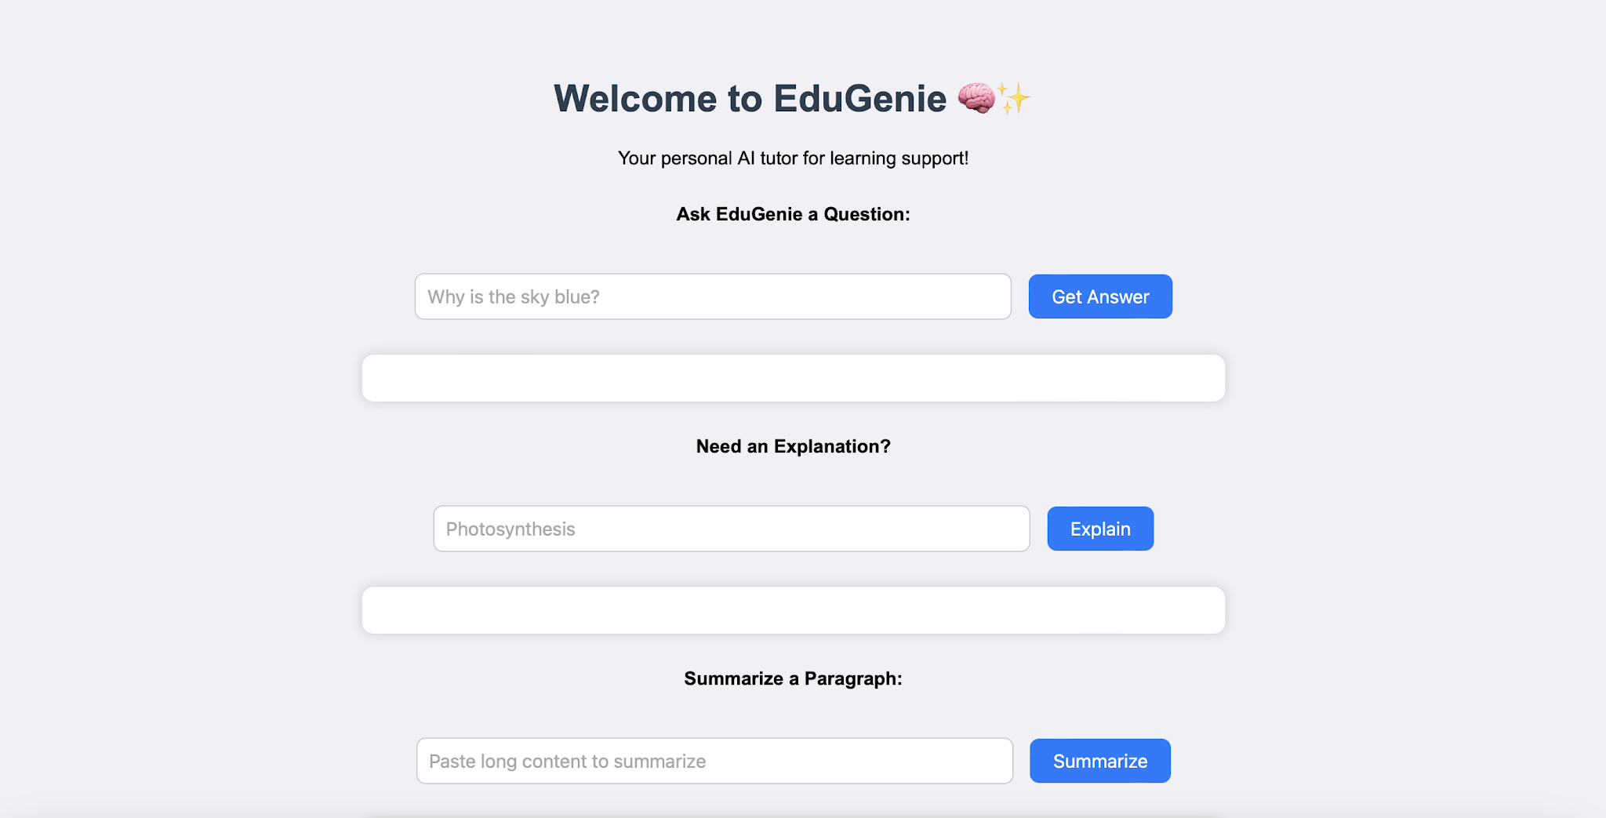
Fig. EDUGENIE

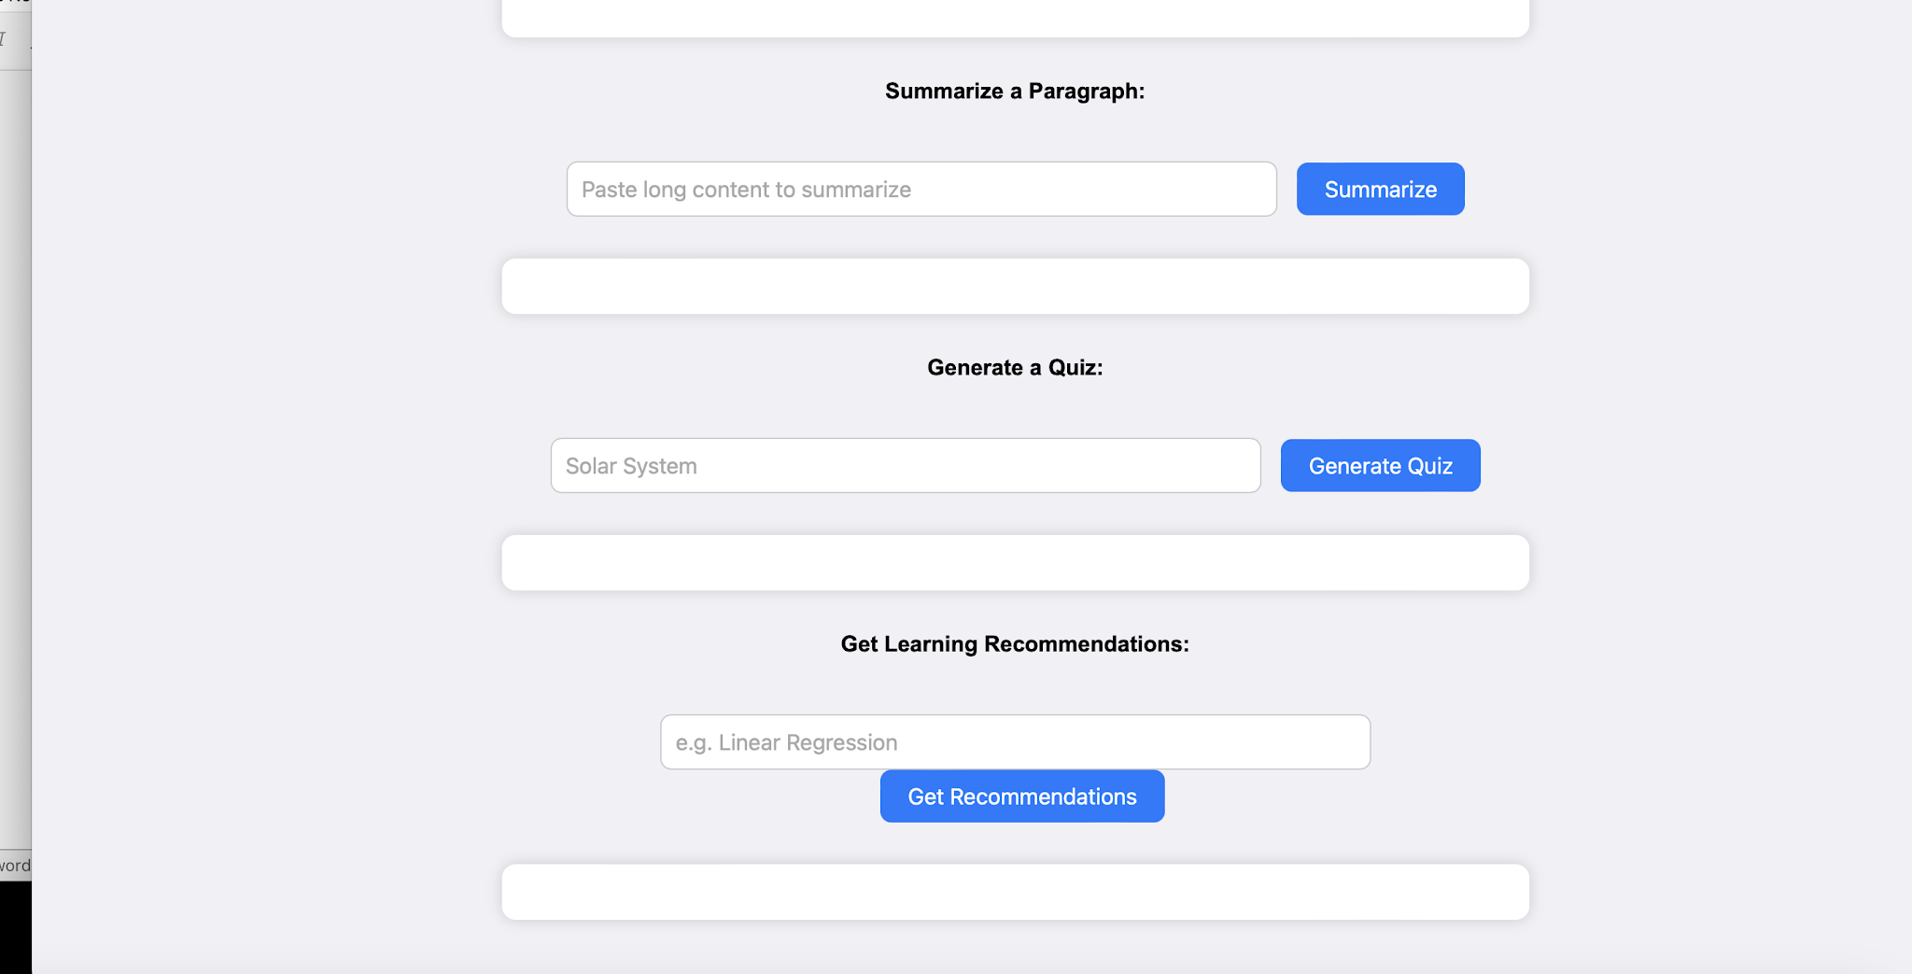
Fig. EDUGENIE

Exploring EduGenie:

  - Asking questions:

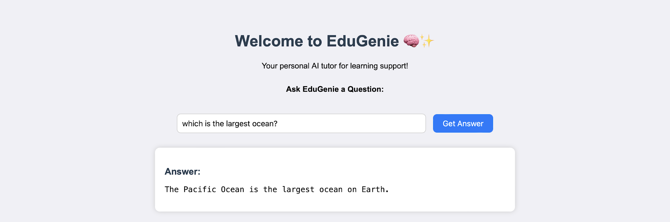

  - Explanation of any topic:

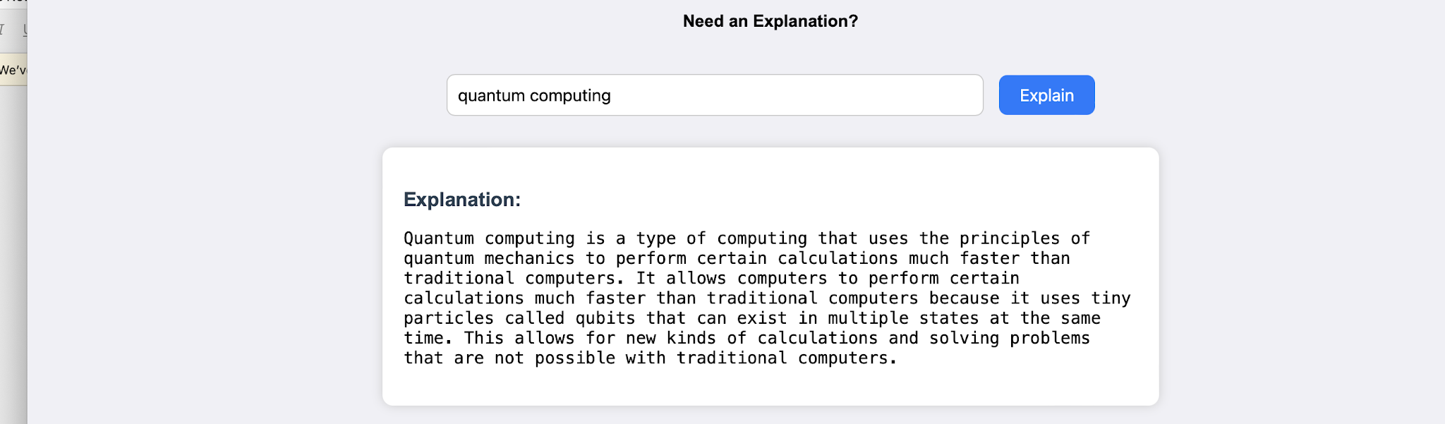
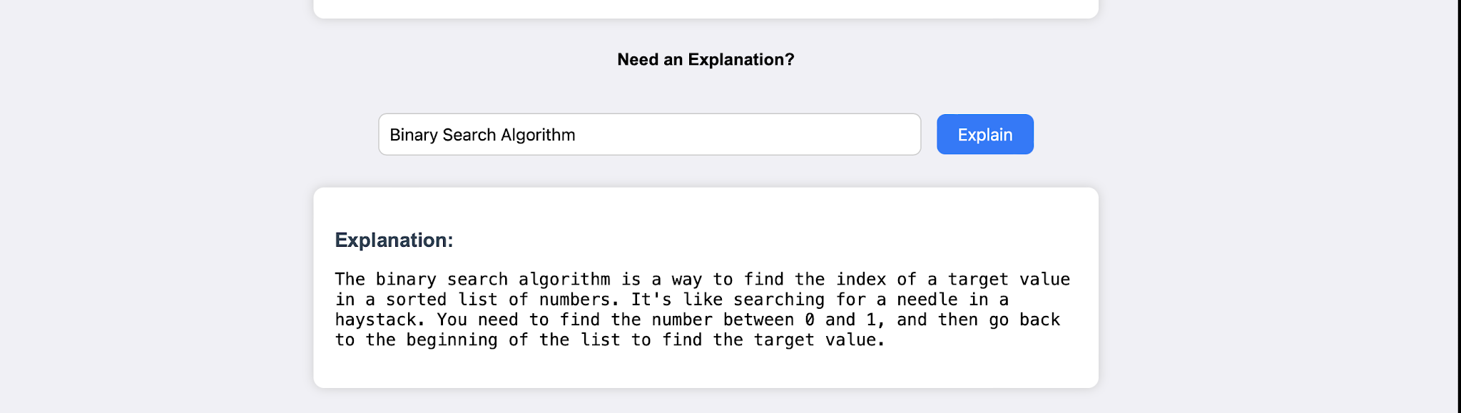
  - Summarising long paragraphs:
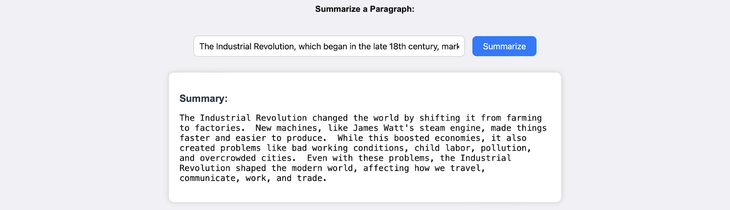

  - Generating quizzes:

It generates three questions with 4 options each. It corrects the answer if chosen wrong.
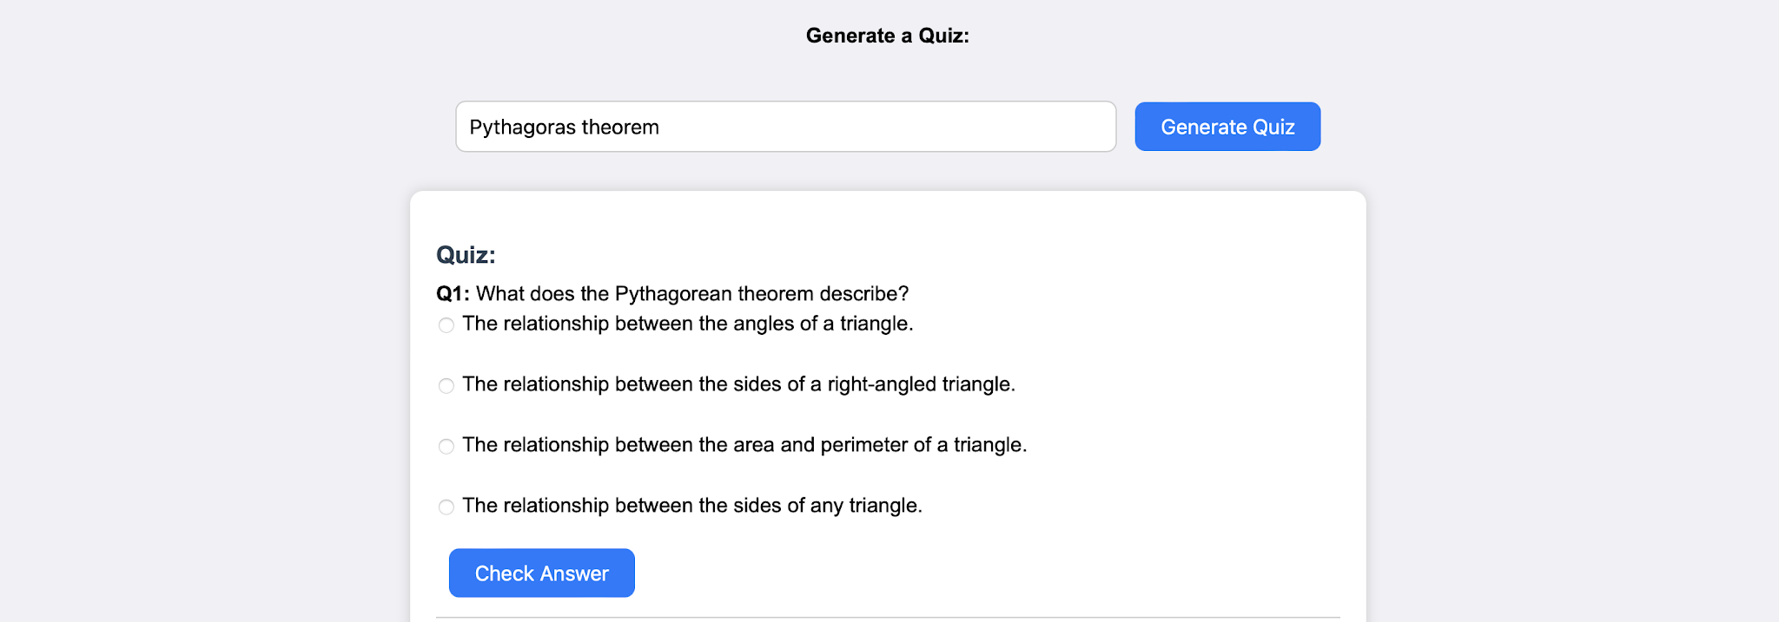
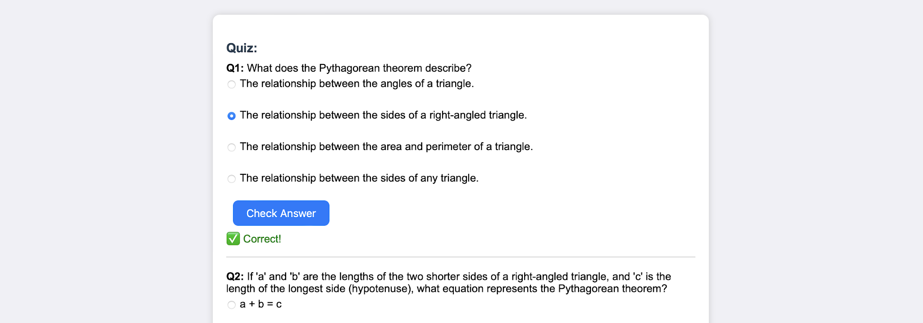
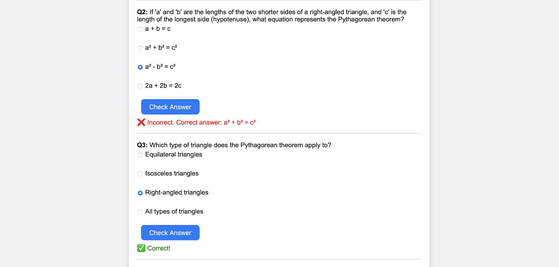

  - Guiding with learning recommendations from beginners level to advanced level
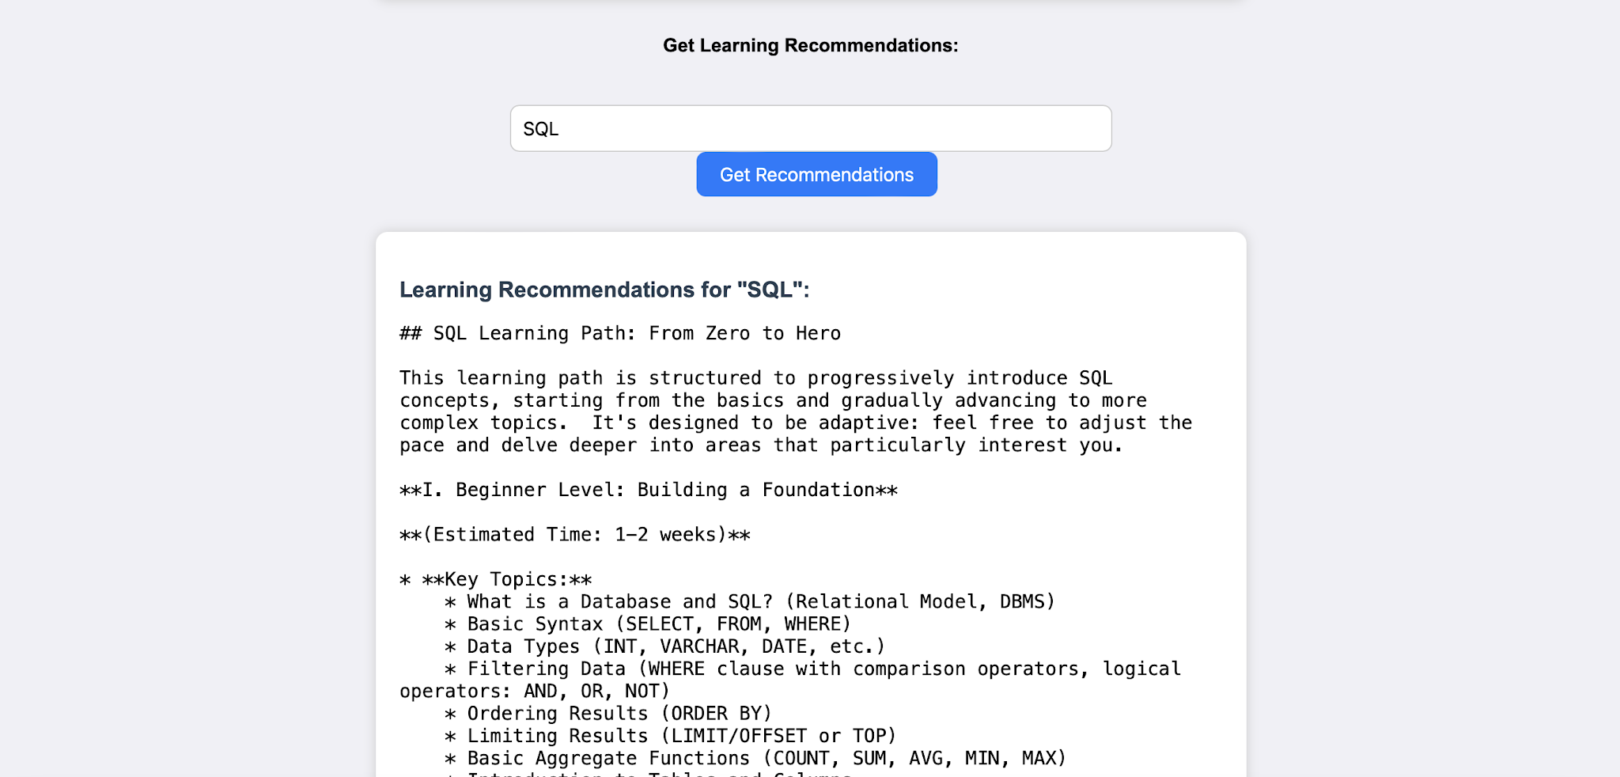
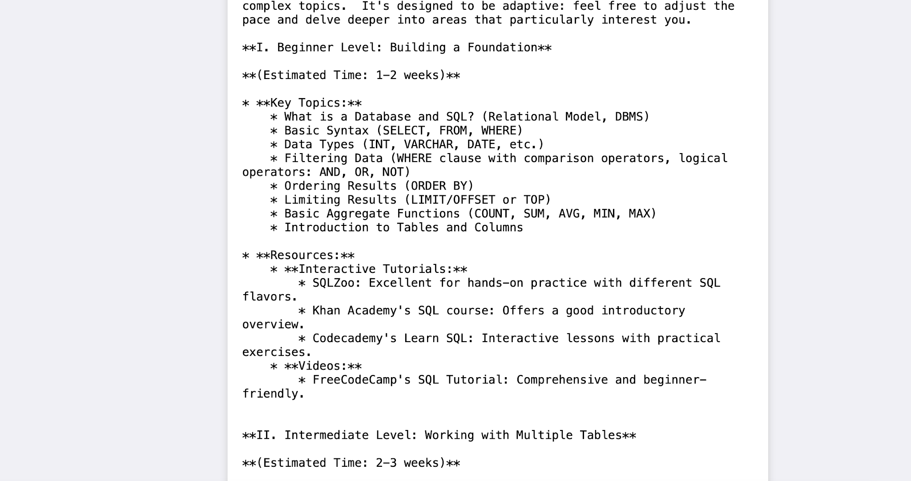
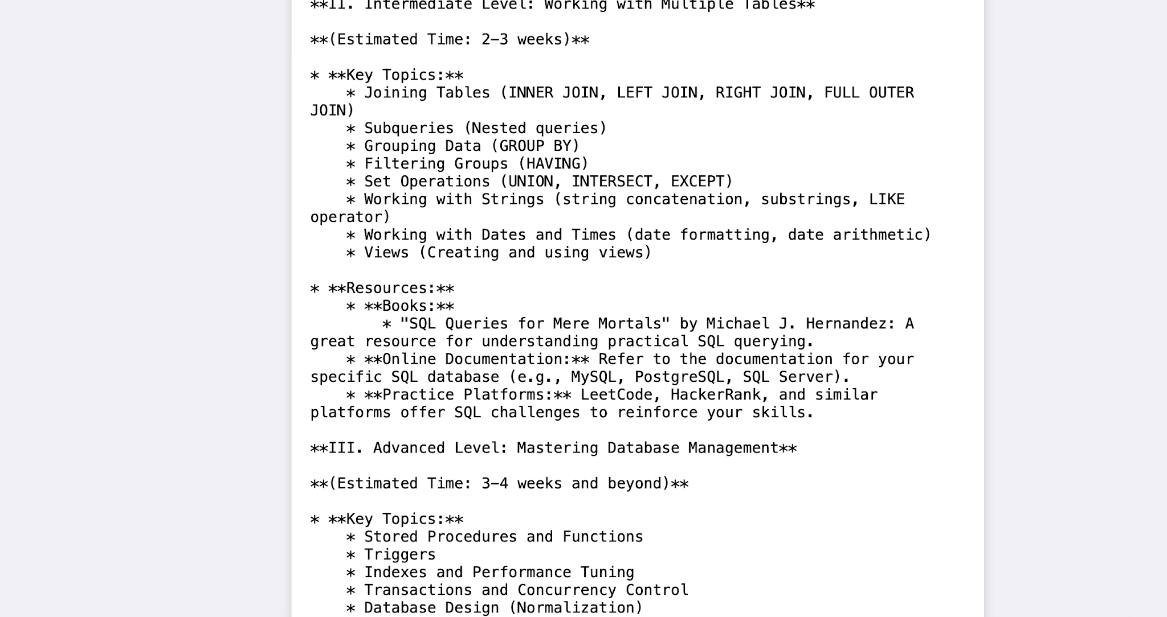
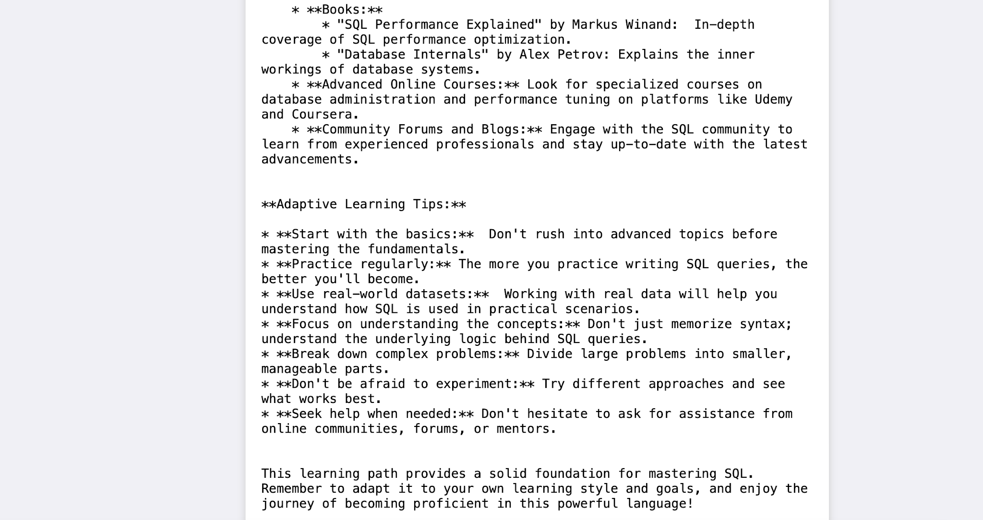
It provides along with details of resources from where to learn and stepwise guidance through-out.

Conclusion:
EduGenie has been developed as a robust and accessible AI-powered educational assistant that seamlessly integrates cloud-based intelligence with an intuitive, low-footprint web interface. Designed to support self-learners, educational institutions, and content platforms, EduGenie democratizes learning by simplifying complex concepts, providing instant question-and-answer interactions, generating personalized quizzes, offering detailed summaries, and tailoring smart learning paths based on individual needs. Its lightweight infrastructure ensures that even users with minimal hardware resources can access high-quality, personalized education without barriers.
Throughout the development of EduGenie, the project achieved key milestones in AI integration, user experience design, and content adaptability. Leveraging advanced generative AI, it transforms static learning into a dynamic and interactive process. The platform's simplicity and clarity cater to learners of all levels—especially those who may find traditional educational content overwhelming or inaccessible. The modularity of the platform further allows for easy future upgrades, while its cloud-based backend ensures scalability and data-driven intelligence.
However, the development journey came with its own set of challenges. Ensuring accuracy in AI-generated responses, maintaining performance across devices, and balancing personalization with general usability were significant hurdles. Overcoming these required continuous testing, fine-tuning AI prompt structures, optimizing the UI for clarity, and addressing data privacy concerns. Yet, these challenges provided valuable learning outcomes—especially in areas like prompt engineering, cloud integration, user-centric design, and scalable architecture.
Looking ahead, EduGenie holds immense potential for enhancement and expansion. One promising direction involves the integration of voice-based interaction, enabling users to learn hands-free using spoken commands and queries—a particularly useful feature for accessibility and multitasking. Multilingual support is another key frontier, helping bridge language barriers and reaching a broader global audience. A mobile application is also envisioned to make learning available anytime, anywhere, with offline features for uninterrupted access.
Furthermore, future iterations of EduGenie could incorporate progress tracking dashboards, allowing users to visualize their learning journey through metrics and insights. The addition of gamified elements such as badges, learning streaks, and challenge-based assessments can boost engagement and motivation. Adaptive learning paths powered by data analytics can guide users more intelligently through content based on their strengths and weaknesses.
From a collaboration perspective, EduGenie can evolve to support group study sessions, teacher or parent dashboards, and integration with Learning Management Systems (LMS) such as Moodle or Google Classroom. Input recognition for images and PDF files can expand how students interact with content, enabling snapshot-based doubt solving and resource summarization. Real-time sync and smart notifications will also improve continuity and interactivity.
In conclusion, EduGenie is not just an AI tool—it’s a foundation for the future of personalized, inclusive, and intelligent education. By bridging gaps in access, comprehension, and adaptability, it redefines the learning experience for digital natives and underserved communities alike. As it continues to evolve, EduGenie is poised to become a comprehensive learning companion for the modern era—smart, scalable, and learner-first.

Submitted by:
Tella Divya Sree
Mentor: Siri
Date: 11/04/2025

